# How to Find Median in SQL Server? – Interview Question of the Week #116

April 2, 2017[Pinal Dave](https://blog.sqlauthority.com/author/pinaldave/)[SQL Interview Questions and Answers](https://blog.sqlauthority.com/category/sql-interview-questions-and-answers/)[2Comments](https://blog.sqlauthority.com/2017/04/02/find-median-sql-server-interview-question-week-115/#comments)

**Question:** How to Find Median in SQL Server?

**Answer:** Before we see the answer, let us first see the definition of median.

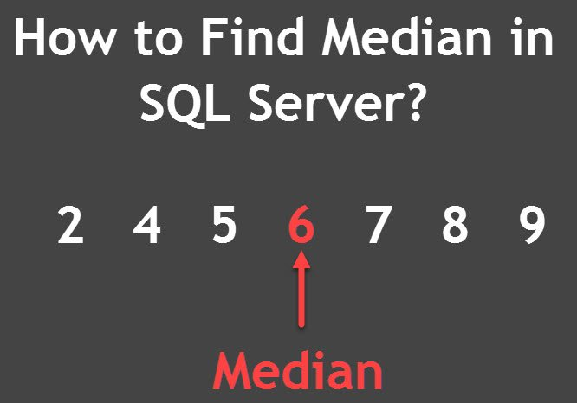

Defination of Median as per [Wikipedia](https://en.wikipedia.org/wiki/Median): The median is the value separating the higher half of a data sample, a population, or a probability distribution, from the lower half. In simple terms, it may be thought of as the “middle” value of a data set.

[](http://bit.ly/solarwinds-12steps)

There is no MEDIAN function in T-SQL. If, however, you are running SQL Server 2012 or 2014, there is an easy workaround.  In 2012, Microsoft introduced a new function called PERCENTILE_CONT. Given a percent rank and a set of values, PERCENTILE_CONT will return the value ranked at that percent. If there is not an exact value found at the rank, PERCENTILE_CONT will interpolate the answer instead. If you supply 0.5, meaning 50%, PERCENTILE_CONT will return the median value.

Let us see a simple example:

|  |  |
| --- | --- |
| 1  2  3  4  5  6  7  8  9 | USE AdventureWorks  GO  SELECT SalesOrderID, OrderQty, ProductID,  PERCENTILE_CONT(0.5) WITHIN GROUP (ORDER BY ProductID)  OVER (PARTITION BY SalesOrderID) AS MedianCont  FROM Sales.SalesOrderDetail  WHERE SalesOrderID IN (43670, 43669, 43667, 43663)  ORDER BY SalesOrderID DESC  GO |

The above query will give us the following result:

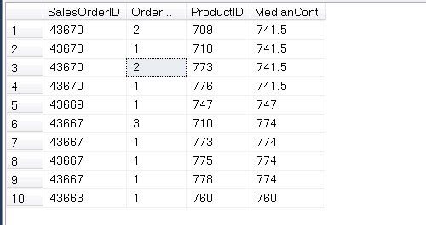

You can see that I have used PERCENTILE_COUNT (0.5) in the query, which is similar to finding median. Let me explain above diagram with little more explanation. The definition of median is as following:

In case of Even Number of elements = In order list, add the two digits from the middle and divide by 2  
In case of Odd Numbers of elements = In order list, select the digits from the middle

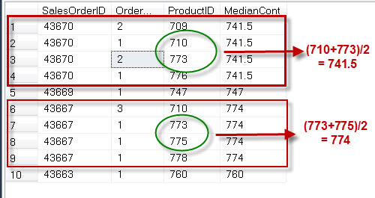

I hope this example gives clear idea how PERCENTILE_CONT () works and help us find the median.

Here are some additional resources:

* [SQL SERVER – What are T-SQL Median? – Notes from the Field #090](https://blog.sqlauthority.com/2015/07/23/sql-server-what-are-t-sql-median-notes-from-the-field-090/)
* [SQL SERVER – Introduction to PERCENTILE_CONT](https://blog.sqlauthority.com/2011/11/20/sql-server-introduction-to-percentile_cont-analytic-functions-introduced-in-sql-server-2012/)([) – Analytic Functions Introduced in SQL Server 2012](https://blog.sqlauthority.com/2011/11/20/sql-server-introduction-to-percentile_cont-analytic-functions-introduced-in-sql-server-2012/)

Reference:**Pinal Dave (**[**http://blog.SQLAuthority.com**](https://blog.sqlauthority.com/)**)**